wDatabase System Engineering and Distributed Backend Development
Course Code: 25CS13002E
ROLL NO:2520030527
NAME: K.Vansika Reddy

SQL PRACTICE NOTES - PHYSICIAN & DEPARTMENT TABLES

Query 1: Create Data Base
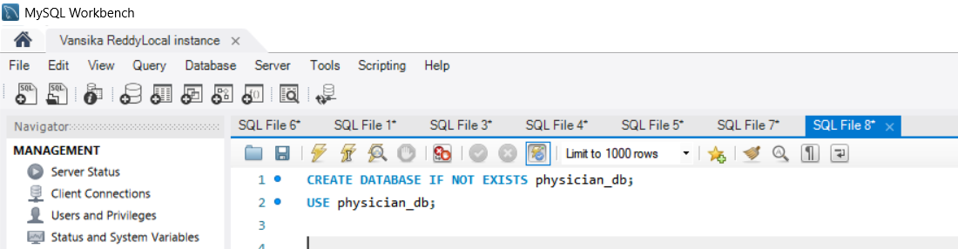

Output:
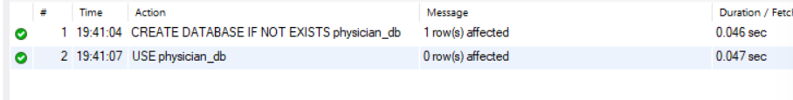
Query 2: CREATE PHYSICIAN TABLE
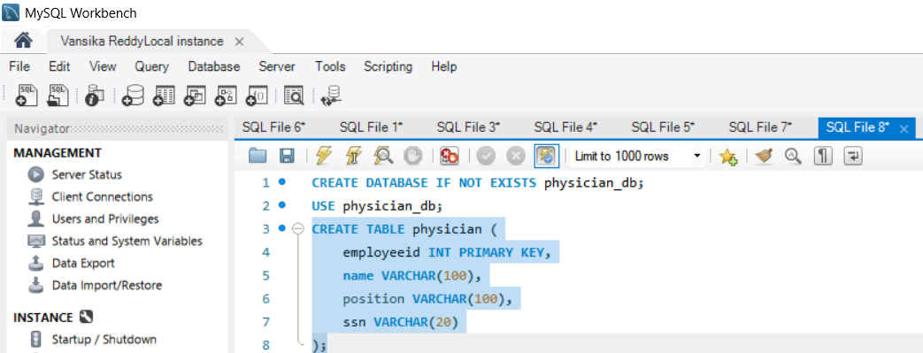

Output:

Query 3: INSERT DATA INTO PHYSICIAN
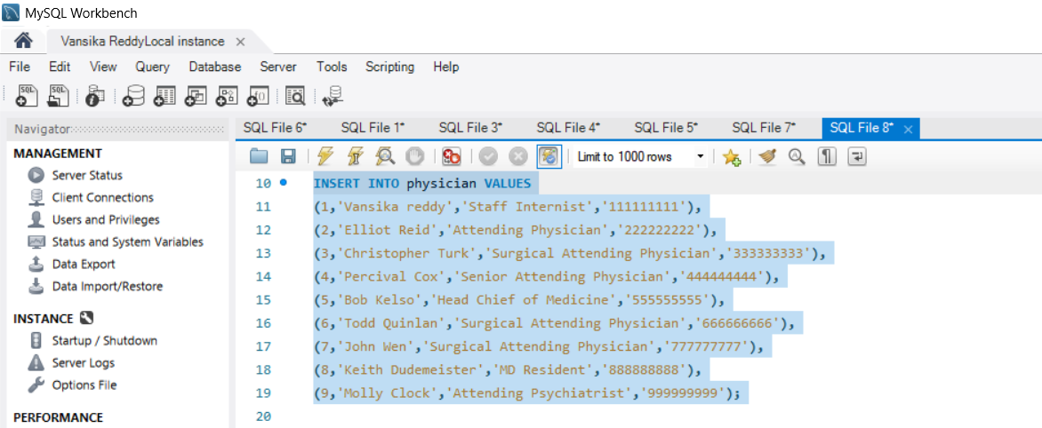

Output:

Query 4: CREATE DEPARTMENT TABLE
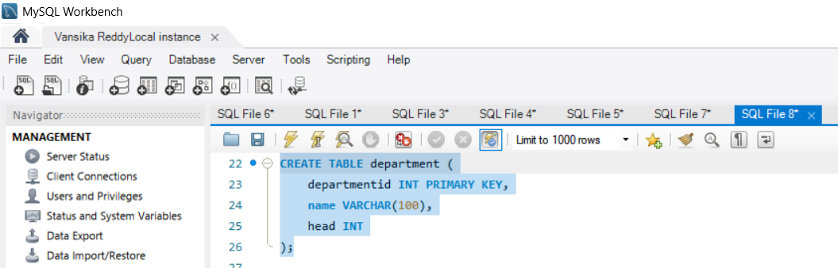
Output:

Query 5: INSERT DATA INTO DEPARTMENT
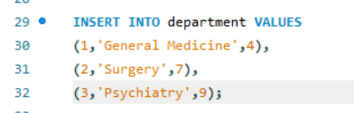
Output:
Query 6: INNER JOIN
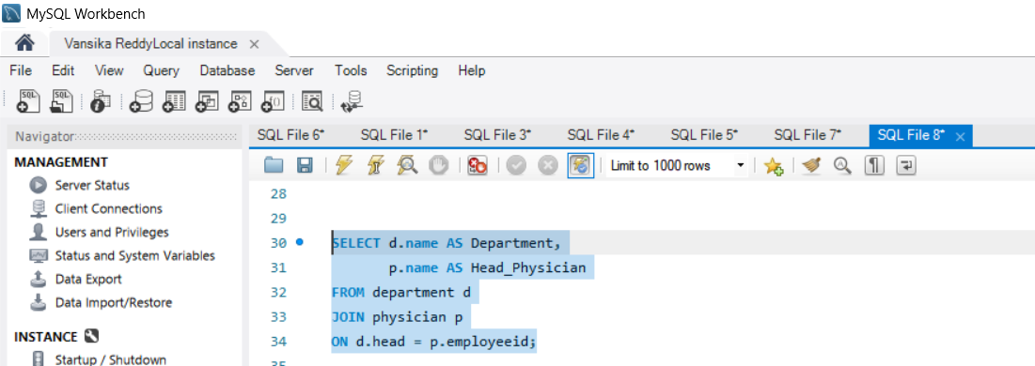

Output:
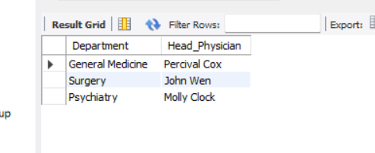

Query 7: WHERE CLAUSE
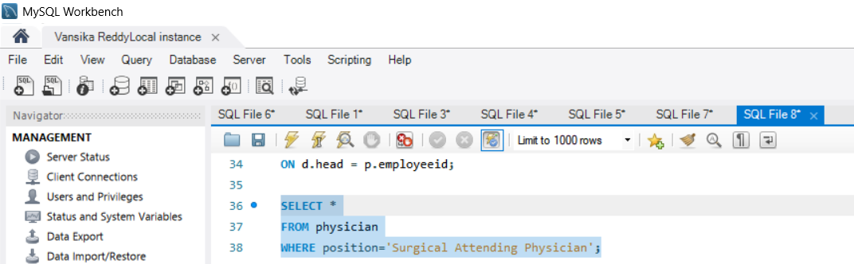

Output:
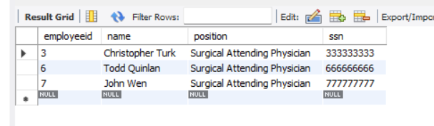

Query 8: WHERE + LIKE
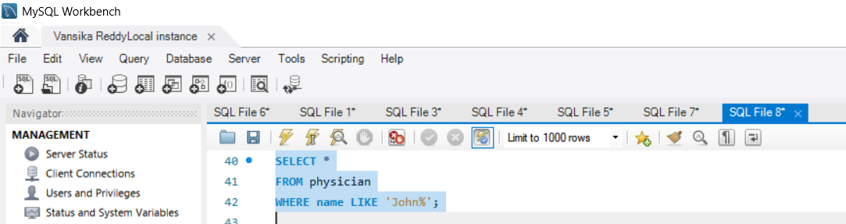

Output:
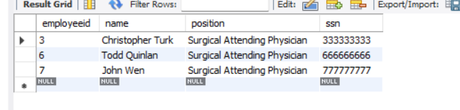

Query 9: COUNT()
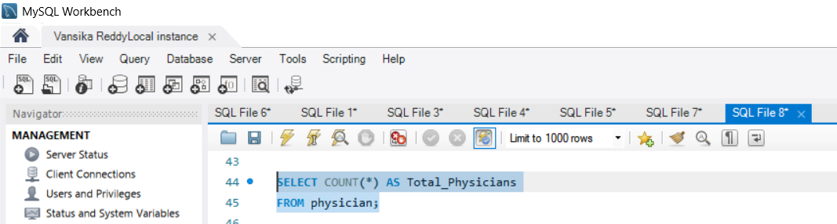

Output:
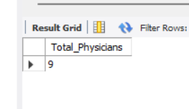

Query 10: COUNT DISTINCT
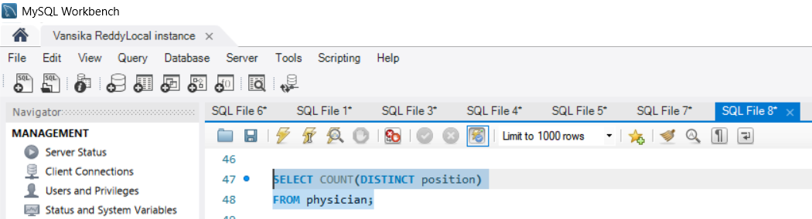
Output:
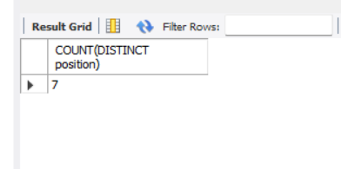

Query 11: GROUP BY
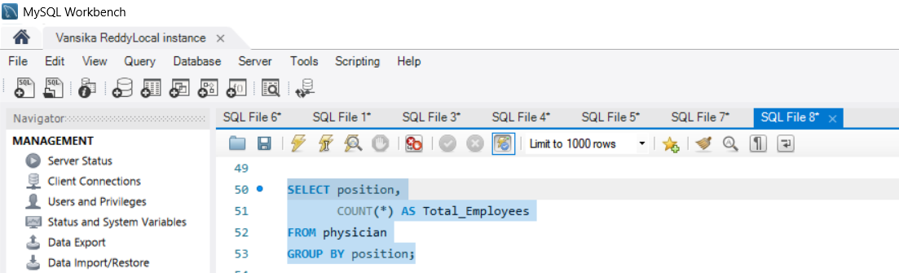

Output:
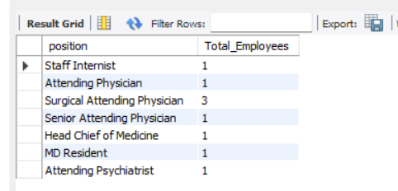

Query 12: GROUP BY + HAVING
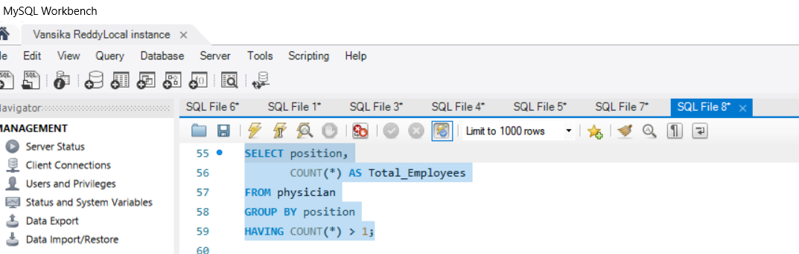

Output:
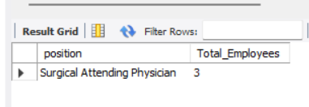

Query 13: ORDER BY
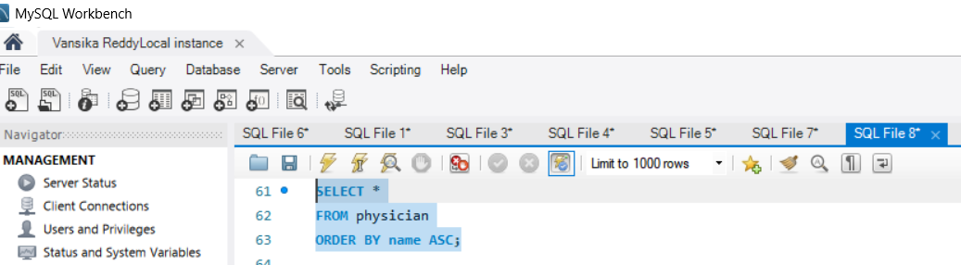

Output:
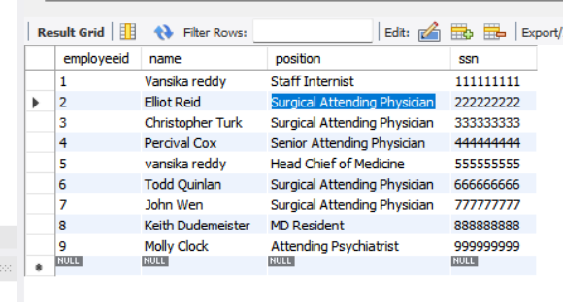

Query 14: ORDER BY DESC
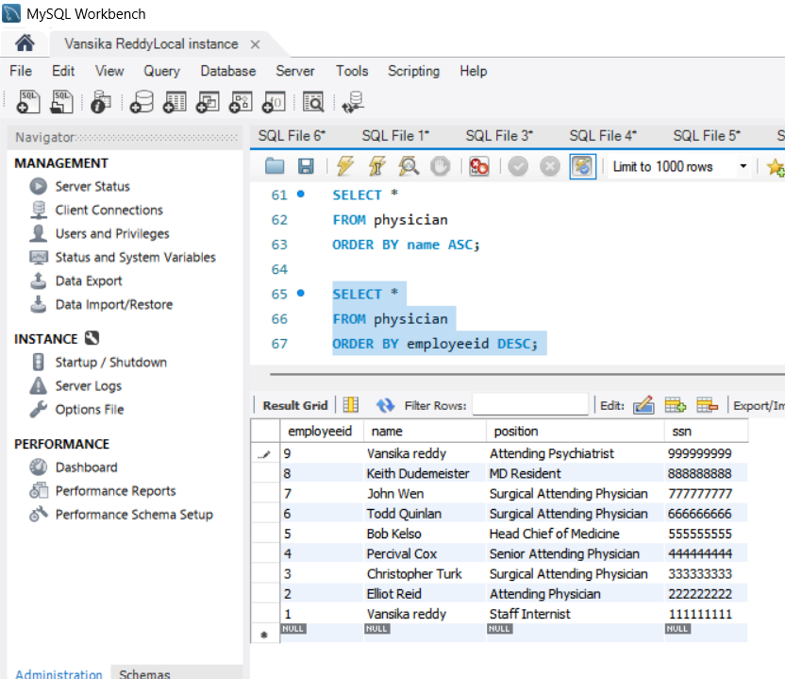
Output:

Query 15: WHERE + IN
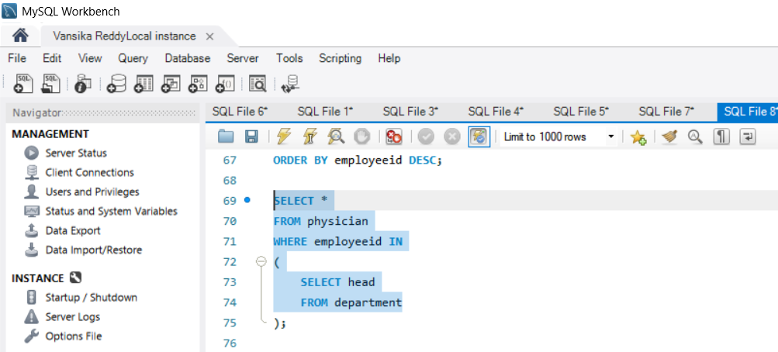

Output:
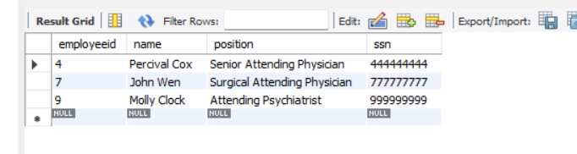

Query 16: SUBQUERY
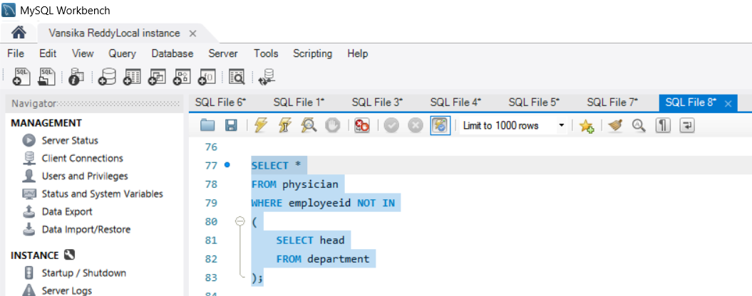

Output:

Query 17: GROUP BY + ORDER BY
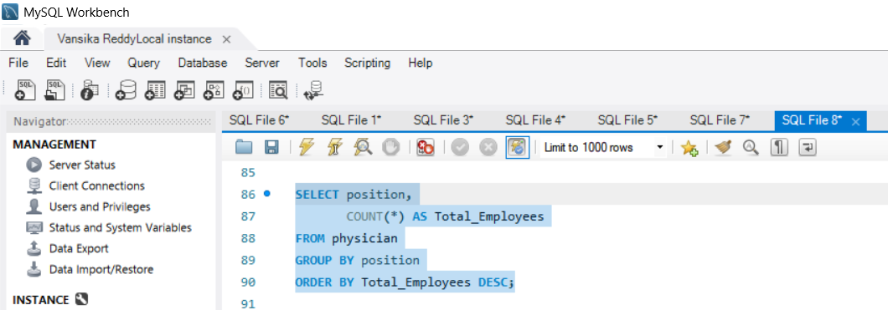

Output:
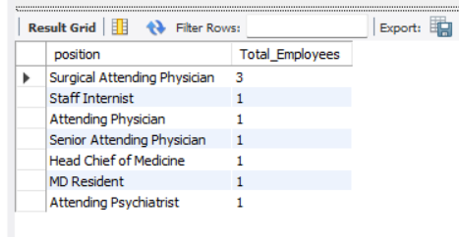

Query 18: WHERE + LIKE
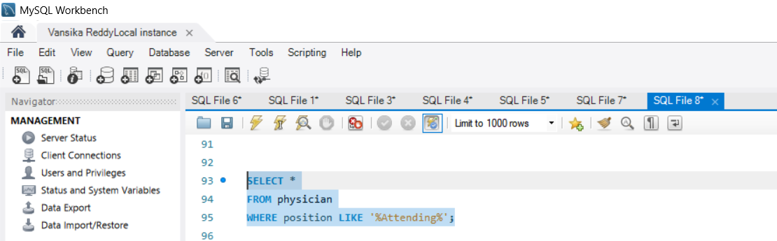

Output:
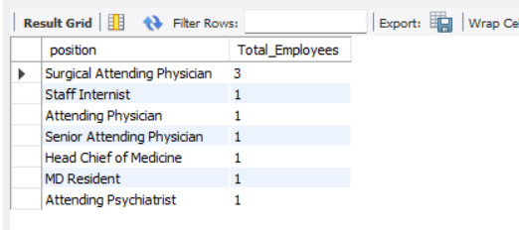

Query 19: JOIN + WHERE
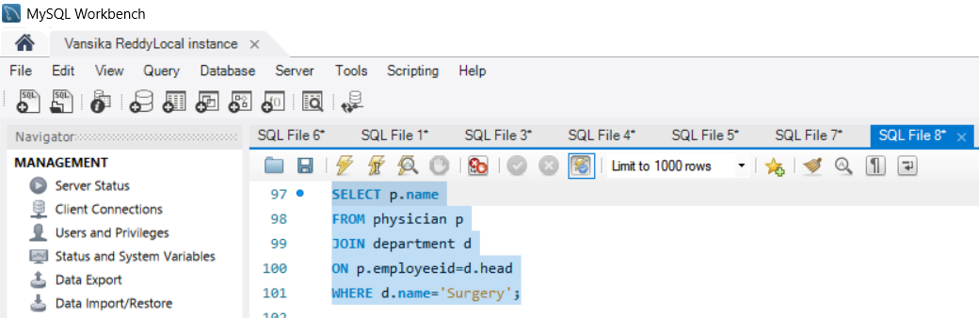

Output:
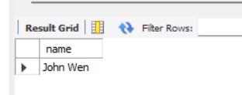

Query 20: JOIN + ORDER BY
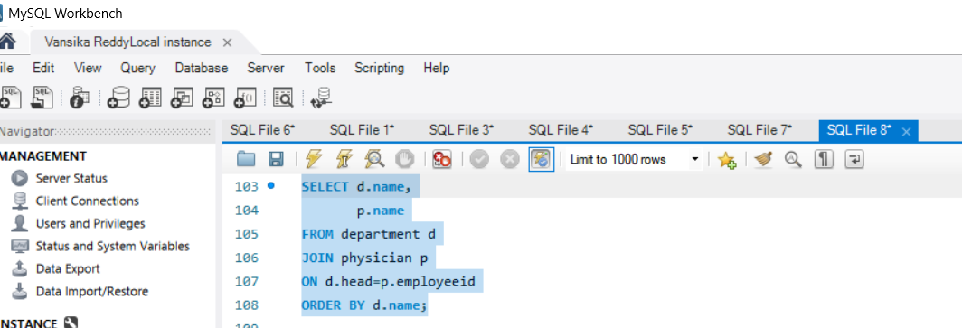

Output:
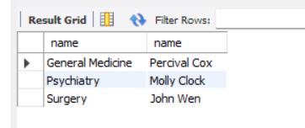

Query 21: WHERE + NOT LIKE
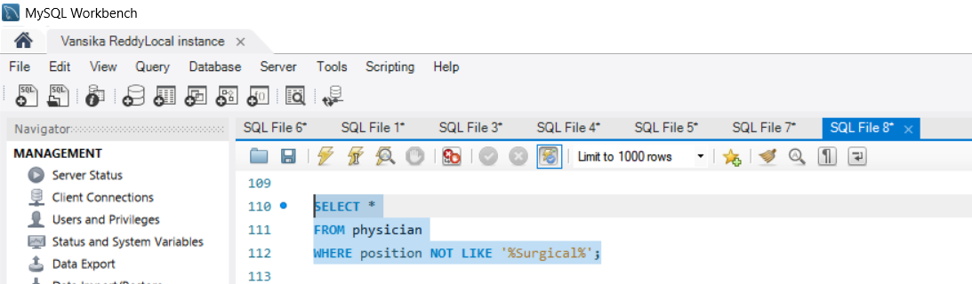

Output:
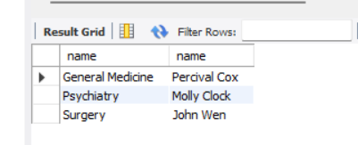

Query 22: COUNT + HAVING
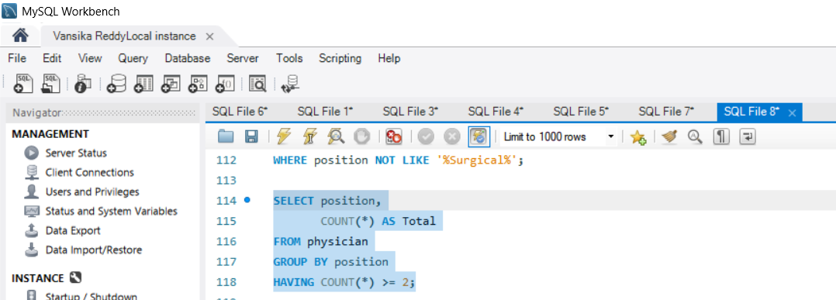

Output:
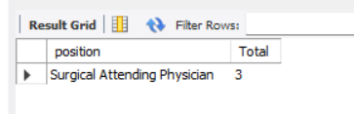

Query 23: EXISTS
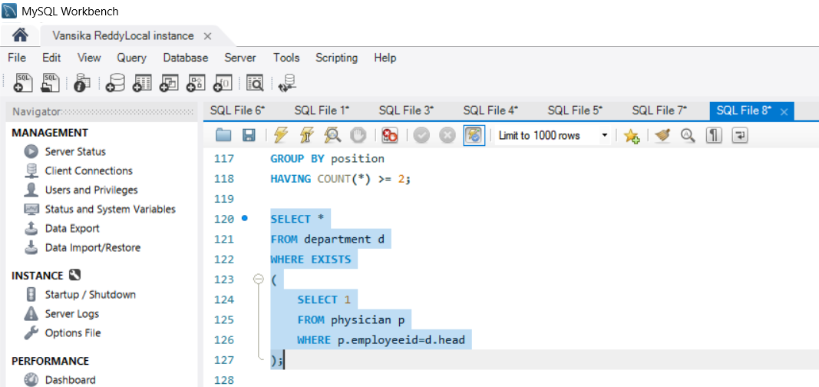

Output:
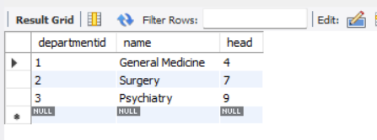

Query 24: MAX()
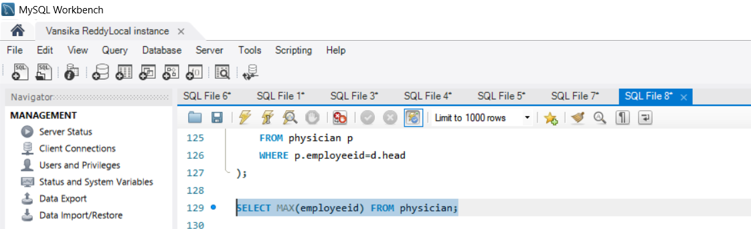

Output:
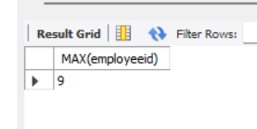

Query 25: MIN()
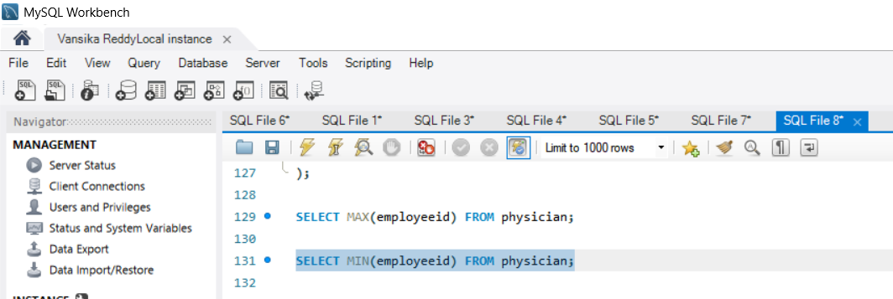

Output:
